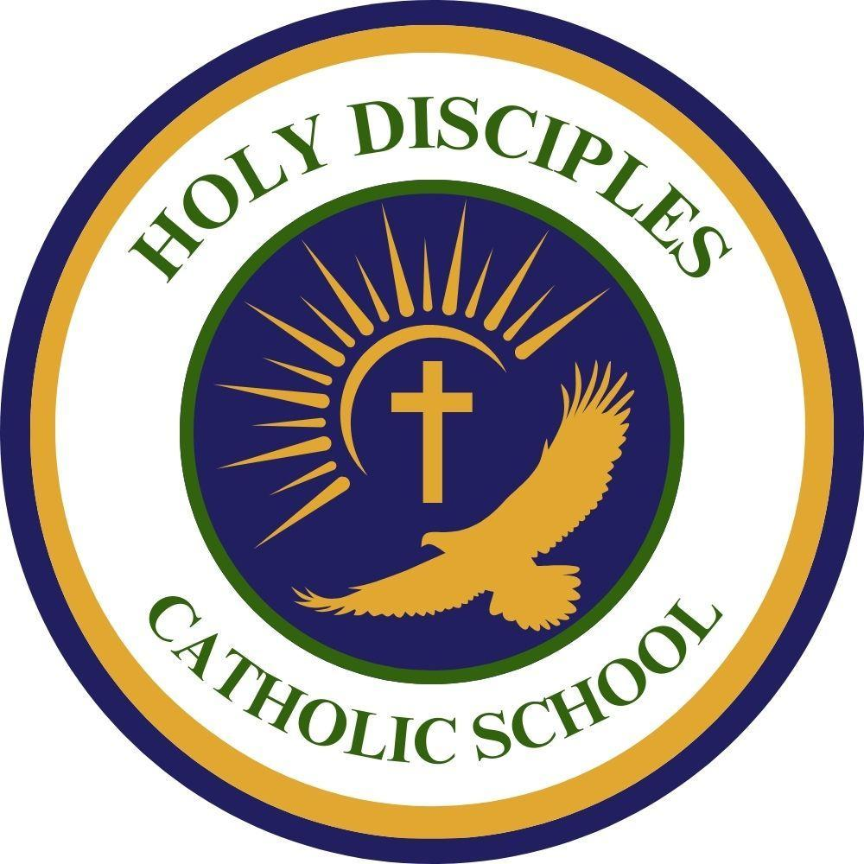
Holy Disciples Catholic School 2026-2027 Annual Auction Gala
Sponsorship & Advertising Response Form

The annual auction gala to benefit Holy Disciples School will be held on Saturday, April 3, 2027, at the Grand Oak Villa. This event raises essential funds to fulfill our mission to maintain a vibrant Catholic school focused on academic excellence, leadership, and daily opportunities for students to work towards solutions to solve real-world problems and serve others in need. This year’s goal of $35,000 will be used to purchase materials and equipment for academic programs, upgrade classroom technology to deliver instruction to students, and offer other innovative programs which will provide students with hands-on opportunities to imagine, design and build. Your help will ensure our school campuses continue to be safe and inviting places to learn.

Event Sponsors
In addition to providing you a tax deduction (Tax ID # 06-0653124) to the full extent allowable by law, your name and/or company name will be prominently recognized in the school community, at the event and highlighted in the special sponsor and advertising sections of the auction program.

Please select your sponsorship level (sponsor packages are detailed in the attached)
- Heads/Tails Game Sponsor- $10,000
- Presenting Sponsor- $2,500
- Platinum Sponsor- $2,000
- Gold Sponsor- $1,000
- Silver Sponsor- $500

My sponsor ad artwork is:
⬜ Enclosed ⬜ Use last year’s ⬜ Will be emailed ⬜ No ad necessary ⬜ Contact me

Event Advertisers
Your name and/or company name will be featured in the advertising sections of the auction program. This is also a great way to acknowledge a student.

Please select your advertisement size:
- Full Page Black and White Ad- $300
- Half Page Black and White Ad- $200
- Quarter Page Black and White Ad- $200
- Student Spotlight- $175

My advertising ad artwork is:
⬜ Enclosed ⬜ Use last year’s ⬜ Will be emailed ⬜ No ad necessary ⬜ Contact me

Your Information

Name(s):___________________________ Company Name: ____________________________
Mailing Address:
______________________________________________________________________________
Preferred Phone: ____________________________ Email:___________________________

School Family Name for Fundraising Credit: __________________________

- School families earn 25% fundraising credit if they purchase an advertisement for their business.
- School families earn 25% fundraising credit if they get an advertisement from an employer, family or friends’ business.

Please make checks payable to:
Holy Disciples Catholic School
My payment is:
⬜ Enclosed

Please email ad to: holydisciplesauction@gmail.com
Mail to: Holy Disciples Catholic School
Attn: Auction Sponsorship Committee
760 Main St
Watertown, CT 06795

Questions? Please contact: Mrs. Stephanie Devino, Auction Chair at holydisciplesauction@gmail.com

Thank you for becoming a sponsor or placing an ad. Please don’t forget to email your ad.

We also welcome your attendance at the event. Tickets will go on sale in the coming school year.

Tickets are available through the school office by calling 860-274-9208 or 860-945-0621, or by emailing the auction committee at holydisciplesauction@gmail.com

Visit our auction website @ https://givegrove.com/hdcsauction for more information or to donate now!

